**Name: Jomol R.K**

**Roll No:09**

**Batch: MCA**

**Date:31/03/22**

**NETWORKING & SYSTEM ADMINISTRATION LAB**

**Experiment No.: 4**

**Aim**

**Familiarization of basic LINUX commands**

**Procedure:**

1. **cat -n <filename.txt>**

**contents with line numbers**

**syntax:**

**$cat -n b1.txt**

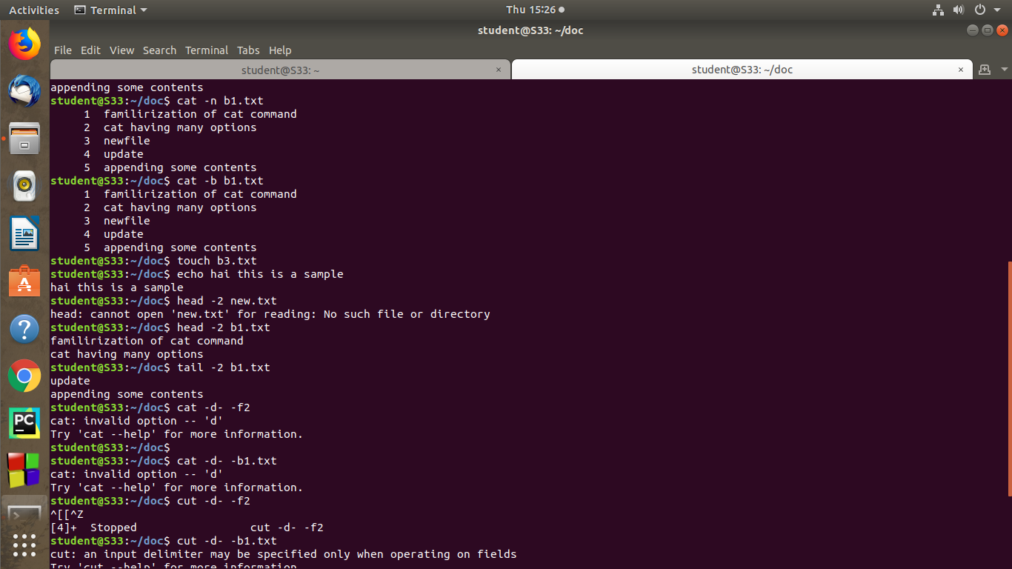**Output:**

1. **cat -b <filename.txt>**

**remove the empty file and redirect the line numbers**

**syntax:**

**$cat -b b1.txt**

**output:**

1. **touch <filename.txt>**

**empty file is created**

**syntax:**

**$touch b3.txt**

**output:**

1. **echo “contents” >> <filename.txt>**

**adding contents to an empty file**

**syntax:**

**$echo contents >> b3.txt**

** output**

**5.head –(line number)<filename.txt>**

**By default 10 lines is displayed from top**

**syntax:**

**$head -2 new.txt**

**output:**

**6.tail –(line number)<filename.txt>**

**last 10 lines displayed**

**syntax:**

**$tail -2 b1.txt**

**output:**



**7.cut -d- -<f1/f2> filename.txt**

**This command is used to cut and the display the contents based on the delimiter given.**

**syntax :**

**$ cut -d- -f2 filename.txt**

**Output:**

